

‘Be kind, work hard and fly high.’
Wednesday 26th March 2025

Dear Parents and Carers,
We enter the last two weeks of the spring term – Wow, time is flying! It is remarkable how quickly the weeks have unfolded this term woven with learning, growth and shared experiences.

This term, we have witnessed some lovely experiences across the school, from the intellectual curiosity displayed in our classrooms to the school trips and residentials that have taken place. We have seen resilience in the face of challenges and a commitment to fostering a supportive and inclusive community. These moments, both large and small, are the cornerstones of our school's ethos and they are what make our collective journey so meaningful.
In these final two weeks, we encourage our children to maintain their focus and dedication, ensuring they conclude the term with a sense of accomplishment. It is also a time to celebrate the progress made and to acknowledge the hard work of everyone involved.
We also wish to take this opportunity to express our sincere gratitude for your continued support and partnership. Your involvement is invaluable, and we deeply appreciate the collaborative spirit that defines our school community.
Easter Bonnet Parade – Friday 4th April

On Friday 4th April, we will be having an Easter Bonnet Parade in school. Grab your bonnet, get creative and get ready to take part in the class parade. All children will receive a small Easter gift and there will be prizes for the winning bonnets. We would love to see your children come into school wearing their Easter Bonnets. This date will also be a non-uniform day.

Diary Dates – Including Holiday Dates 2024/2025

 | 2025
 | March
Wednesday 26th | Height and Weight Measurements – FS2 and Year 6
Thursday 27th & Friday 28th | 1:00pm Family Celebrations events (over 2 days)
 | April
Tuesday 1st | 9:15am EYFS Easter ‘Eggs’travaganza 2025
Wednesday 2nd | 1:00pm Year 3/4 Easter Craft afternoon
Thursday 3rd | Easter Dinner
Friday 4th | Non-Uniform Day / Easter Bonnet Parade
Friday 4th | Last day of Spring 2 term
Tuesday 22nd | First day of Summer 1 term
Friday 25th | Year 3 Trip to Creswell Crags
 | May
Monday 5th | BANK HOLIDAY – School Closed
Tuesday 6th | Class photographs
Tuesday 6th | 5:00pm Year 6 Tenby Residential Parent Meeting
Friday 9th | F1 & Y3 Trip to Gladstone Pottery
Monday 12th | Key Stage 2 SATS Week
Thursday 22nd | Sports Day 2025
Thursday 22nd | Last day of Summer 1 term
Friday 23rd | INSET DAY – School Closed
 | June
Monday 2nd | First day of Summer 2 term
Monday 2nd | Year 4 Multiplication Check Week
Tuesday 3rd – 6th | Year 6 Tenby residential
Monday 9th | Phonics Screen Week
Thursday 12th | Reserve Sports Day
Friday 13th | 7:30am Family Breakfast event
Monday 23rd | INSET DAY – School Closed
 | July
Thursday 3rd | 9:30am F2 trip to Pizza Express
Wednesday 9th – 11th | Year 6 pupils transition to Holgate School
Friday 18th | Reports to Parents
Tuesday 22nd | 5:00pm Year 5/6 Summer Production
Wednesday 23rd | 5:00pm Year 5/6 Summer Production
Friday 25th | ‘Transition Day’ into new classes
Tuesday 29th | Last day of Summer 2 term
September
Wednesday 3rd | INSET DAY – School Closed
Thursday 4th | First day of Autumn 1 term for pupils

Cyber Security Training for parents/carers - Thursday 3rd April 2025 (17:00-18:00)

The Nottinghamshire ESHAWH (Education, Safeguarding, Health and Wellbeing Hub) have worked with colleagues from Nottinghamshire Police to organise Cyber Security training sessions for parents – this is due to take place in April 2025. The event has been designed to support parents/carers/families. The training session is free to attend and will take place online via Microsoft Teams – further information and registration links are available below. It would be great to have as many attendees as possible.

- This session will be delivered by Nottinghamshire Police Cyber Protect & Prevent Officers.
- This session is for all parents/carers that are living with or supporting children who are using devices (phones, tablets, or computers).
- The aim of this private session will be to educate parents/carers on best practice when it comes to basic online security and keeping those accounts private.
- The team will also talk about the Cyber Choices programme, which was created to help people, particularly children to make informed choices and to use their cyber skills in a legal way.
Please register for the parent/carer event here:
Cyber Security Training for parents/carers - Thurs 3rd April 2025 (17:00-18:00)


Strategic Staffing Update: School Business Lead
In our ongoing commitment to the strategic development and sustained excellence of Hucknall Flying High Academy, I am pleased to provide a comprehensive update regarding recent staffing transitions within our administrative team.
As you may recall, we advertised the pivotal position of School Business Lead, a role designed to bolster our operational capacity and support the academy's continued growth trajectory. This search was initiated following Mrs Oswin's decision to pursue new professional opportunities, a transition we approached with a focus on both continuity and future advancement.
After a rigorous selection process, I am delighted to announce the appointment of Mrs Dane as our new School Business Lead. Mrs Dane brings with her a wealth of experience and a proven track record in strategic school management. She will officially assume her responsibilities immediately following the Easter break, ensuring a seamless handover and minimal disruption to our daily operations.
Mrs Oswin's dedication and expertise have been invaluable to Hucknall Flying High Academy, over our continued growth since opening in 2019. Her final day in the full-time role will be April 25th. However, we are immensely fortunate that Mrs Oswin will remain with us, transitioning to a consultancy/support role, one day per week. This arrangement will allow us to continue benefiting from her deep institutional knowledge and operational acumen, ensuring the smooth continuation of our financial and administrative processes.
The strategic filling of these roles is a testament to our proactive approach to school management. By securing both a highly qualified new School Business Lead and retaining Mrs Oswin's expertise, we are ensuring that our operational infrastructure remains robust and capable of supporting our ongoing development plans. This strategic alignment will empower us to maintain our focus on delivering exceptional educational experiences for all our students.
We extend our warmest welcome to Mrs Dane and express our deepest gratitude to Mrs Oswin for her dedication over the last 6 years and continued commitment to the sustainability of Hucknall Flying High Academy. We are confident that these staffing arrangements will contribute significantly to the continued success and future growth of our school.
Family Celebrations Event

We look forward to hosting our annual event. Please see below details that were sent out to parents who have booked to attend the event:
Thursday 27th March

1:20pm - 1:40pm Sitting 1 – will include parents with children in Year 1 and their siblings.
2.00pm -2.20pm Sitting 2 – will include parents with children in FS2 (Spitfires) and their siblings.
2.40pm -3.00pm Sitting 3 – will include parents with children in FS1 (Nursery) and their siblings.

Friday 28th March

1:20pm -1:40pm Sitting 1 – will include parents with children in Year 2 and their siblings.
2.00pm -2.20pm Sitting 2 – will include parents with children in Years 3 and 4 and their siblings.
2.40pm -3.00pm Sitting 3 – will include parents with children in Years 5 and 6 and their siblings.


Year 3/4 Easter Craft Event
We eagerly anticipate the vibrant Year 3/4 Easter Craft Event next week. Beyond the creation of charming Easter crafts, this event serves as a vital bridge between home and school, reinforcing the collaborative spirit that underpins our educational philosophy. We believe that parental involvement is instrumental in enriching the learning experience and we warmly invite you to join us in celebrating the creativity and ingenuity of our children.
We encourage you to participate actively, sharing in the joy of creation and witnessing firsthand the dedication and enthusiasm of our Year 3/4 students. This event is not merely a craft session; it is an exercise in community building, a celebration of childhood wonder and a testament to the power of shared experiences.
Detailed information regarding the event's schedule is outlined. We look forward to welcoming you and sharing in the delightful creations of our children.
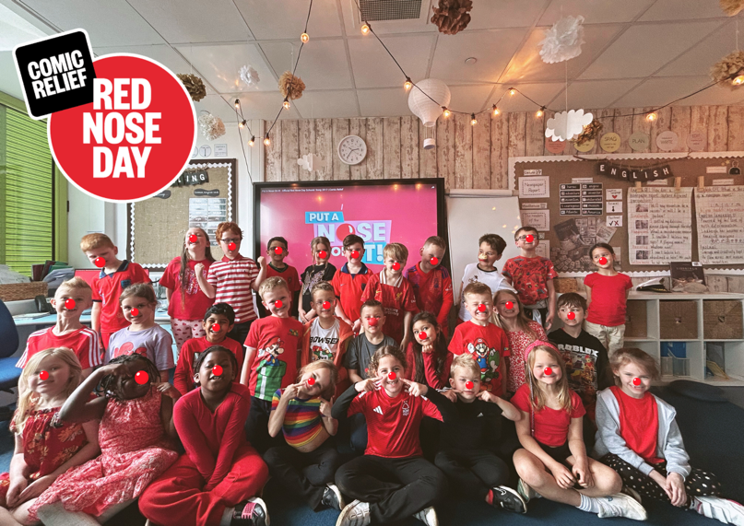
Red Nose Day
Thank you for your donations for the annual Red Nose Day on Friday, it was lovely to see the children in their red clothes too! – We collected £180. Well Done Hucknall FHA!

National Kindness Awards

We invite you to celebrate the compassionate spirit of our children by nominating them for the prestigious National Kindness Awards. This is an exceptional opportunity to recognise and honour the acts of empathy, generosity and thoughtful consideration that enrich our school community. To access the nomination portal and share your stories of their remarkable kindness, please scan the QR code featured in the accompanying image. Let us collectively acknowledge and nurture the values that make our children truly exceptional.

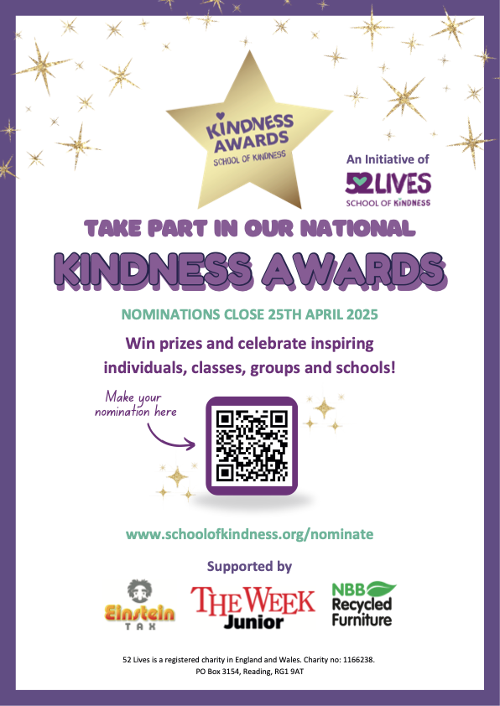

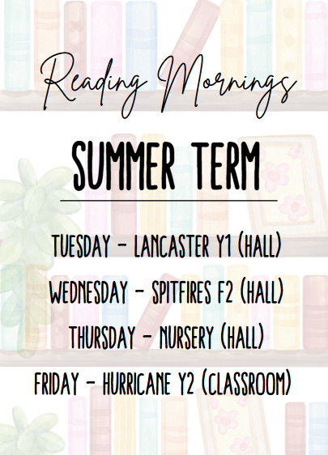
Reading Mornings – Summer Term
As we embark on the summer term, we continue to prioritise the cultivation of a vibrant reading culture within our school community. Our reading mornings have become an integral part of this endeavour, fostering a love of literature and nurturing essential literacy skills. To ensure the continued effectiveness and enrichment of these sessions, we have made some subtle adjustments to the schedule for this term.
The specific days designated for our reading mornings this summer term are detailed alongside. We encourage you to mark these dates in your calendars and support your children in preparing for these enriching sessions. We believe that by working together, we can instil a lifelong passion for reading and equip our children with the tools they need to succeed academically and beyond.

OT Food Club Easter Egg Collection

The OT Food Club is spearheading a community-focused initiative this Easter, aiming to distribute Easter eggs to residents of local care homes and families in need. To facilitate this heartwarming project, Hucknall Flying High Academy will serve as a designated collection point for donations throughout the upcoming term.
We invite you to join us in making a tangible difference in the lives of others by contributing to this fantastic cause. Your generous donations of Easter eggs will help bring joy and a sense of connection to those who may be facing isolation or hardship.
Please drop off your contributions at the school office. Together, we can share the spirit of Easter and make this season a little brighter for everyone in our community.
Thank you for your ongoing support.

Mr K Clowery






